Space, Range and Display

Installing the JDA Applications

UNC path for application installers:

\\uselsfp0002\shared\space, range & display\utils\jda

CD – Full CD copy
Changes – updates, ini files, tables, layouts
Activation key.txt – serial #

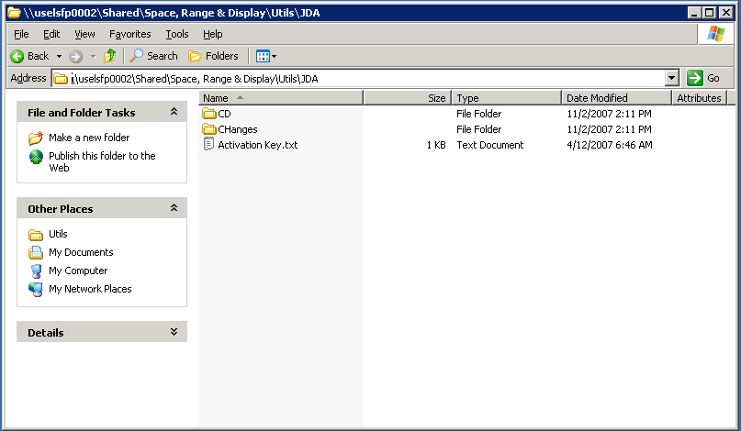

Click Launch.exe to run the install application

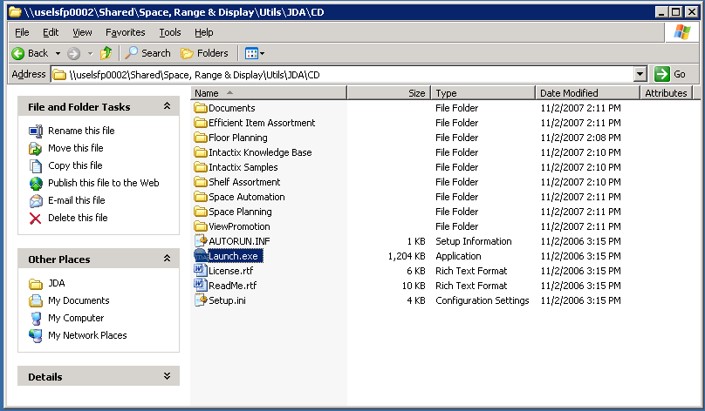

Click Close

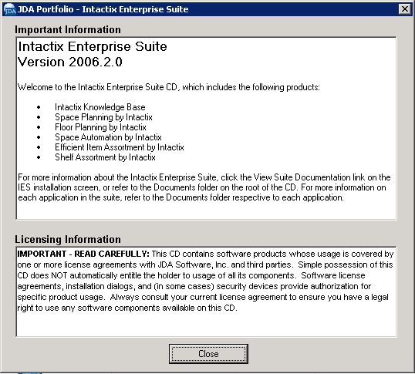

Select

Intactix Knowledge Base
Database Connectivity
Client Components

Space Planning
Floor Planning

Click Install

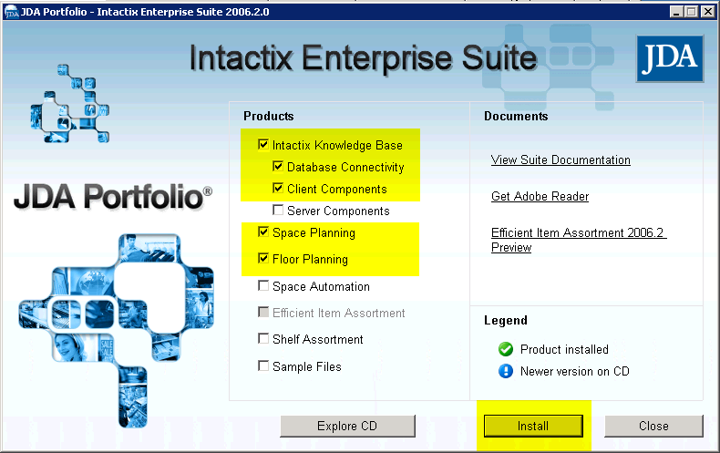

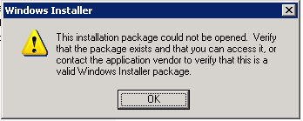

Access each individual folders

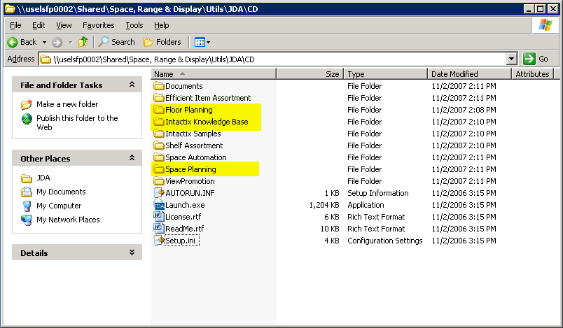

Install JDA Floor Planning

